Practical 2: Creating Database Objects

Learning objectives:
- Exploring the basic ORACLE SQL data types
- Creating a set of database objects with data integrity enforcement
- Inserting and Querying data

What is an ORACLE database
ORACLE defines its database as a collection of physical files that are managed by a single instance of the database software (DBMS). Objects managed by the DBMS include tables, relationships, constraints, views and indexes.

Consider the following simple system of a car workshop.
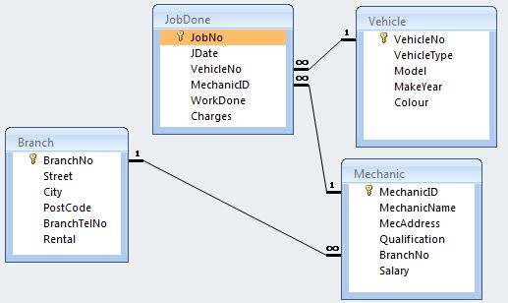

Data definitions

Field Type Field Type Field Type
BranchNo | numeric(4) | JobNo | Numeric(4) | MechanicName | text(20)
Street | text(20) | JDate | date | MecAddress | text(30)
City | text(20) | VehicleNo | text(7) | Qualification | text(30)
PostCode | number(5) | MechanicID | numeric(4) | Salary | $99,999.99
BranchTelNo | text(14) | WorkDone | text(50) | VehicleType | text(20)
Rental | $9,999,999.99 | Charges | $99,999.99 | Model | text(20)
 |  | Colour | text(20) | MakeYear | number(4)

Refer to :
Oracle Database SQL Language Reference, 18c Chapter 2 Basic Elements of Oracle SQL
to choose the appropriate data type for each data field.

Your task:
- Write a script with the appropriate DDL commands to create the vehicle, mechanic, jobdone and branch tables. Ensure your tables have entity integrity and referential integrity.
(This is your preparation before coming to class)

(Reading)
SQL Constraints (pg 8-2 of the Oracle Database SQL Language Reference)
A constraint is a rule placed on a database object that restricts the allowable data values for that database object in some way. Once in place, constraints are automatically enforced by the DBMS and cannot be circumvented unless an authorized person disables or deletes the constraint.

Below are the five types of constraints that are provided by Oracle.
- NOT NULL constraint
- UNIQUE constraint
- PRIMARY KEY constraint
- FOREIGN KEY constraint
- CHECK constraint

- Execute the script to create the database.

- Insert sample data into your tables.

- Additional class exercises
(You will be tested on ALTER TABLE, INSERT and SELECT commands)

HOMEWORK
Re-examine the CREATE TABLE scripts from Practical 1.

Modify the scripts where necessary:
- Ensure that all tables have the necessary Primary Key and Foreign Key declarations.
- Consider to set default values for some of the data items:
e.g. CreditLimit has a default value of 5000.00
- Implement check constraints to ensure the values of data items are within acceptable range.
e.g. There may a maximum/minimum price for items, sale price of a product cannot be a negative value, etc.

